NAME

NAME: ABDULLAH SHAH ALAM
ID: IU04-0123-0462
COURSE: Artifical Intelleigence (LAB)
INSTRUCTOR: Sir Mubassir Ahmed
OEL
SOURCE CODE:

graph = {
0: [0, 1, 2],
1: [0, 2],
2: [0, 1, 4],
3: [0],
4: [2]
}
def bfs_OEL(graph, start):
visited= []
stack = [start]
while stack:
node = stack.pop()
if node not in visited:
visited.append(node)
stack.extend(reversed(graph[node]))
return visited

print("\n \t\t OEL")
print("Code BY:\nAbdullah Shah Alam\n")
result = bfs_OEL(graph,0)
print("DFS TRIVERSAL: ", result)

OUTPUT:
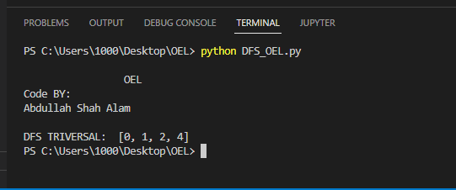

With change of Graph values or nodes

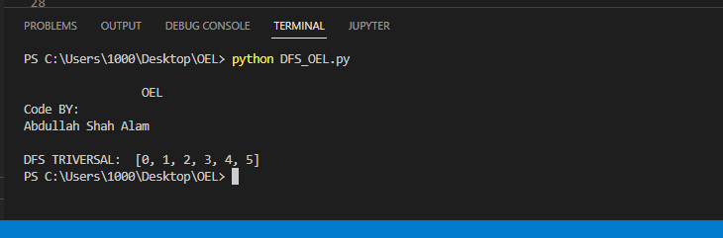

EXPLANATION:
Why we choose this topic?
I want to choose this topic beaceuse it uses in our daily life, to find a folder or to find path in maze, that uses the algorithm of uses the concept of Stack memeory the idea of stack is simple, those who come in last are treated as first , that is why The stack-based approach made logical sense, go deep into one path first before backtracking.

Workflow Explanation
We start by initializing an empty visited list and a stack with the starting node. The loop runs while the stack has elements, each time we pop a node from the back (LIFO), check if its already visited, skip it if yes, otherwise mark it visited and push its neighbors in reversed order back onto the stack. This continues until the stack is empty and we return the visited list.

WORKFLOW:
Stack.extend(reversed(graph[node]))
Push neighbour in order
yes
yes
NO
NO
INITIALE
visited=[] stack =[0]
Node already in visited?
SKIP NODE
Return visted
Visted.append(node)
mark node as visted
Node = stack.pop()
take the last item from stack
Stack is empty?
Start: dfs_OEL (graph,0)

LOOP

